**Bahria University, Lahore Campus**

Department of Computer Sciences

Lab Journal 11

**(Spring 2022)**

|  |  |  |
| --- | --- | --- |
| Course: | **Data Communication and Networks Lab** | Date: |
| Course Code: | CEL - 222 | Max Marks: 10 |
| Faculty’s Name: |  | Lab Engineer: |

Name: ALI HASSAN Enroll No: 03-13521-005

Objective(s) :

To implement Dynamic Host Configuration Protocol.

## Lab Tasks :

**Task 1: What is DHCP?**

A DHCP server, a type of network server, performs an automated distribution and assignment of IP addresses, default gateways, and other network characteristics to client devices. To reply to broadcast requests from clients, it uses the widely used Dynamic Host Configuration Protocol, or DHCP.

**Task 2: Implement Dynamic Host Control Protocol using server.**

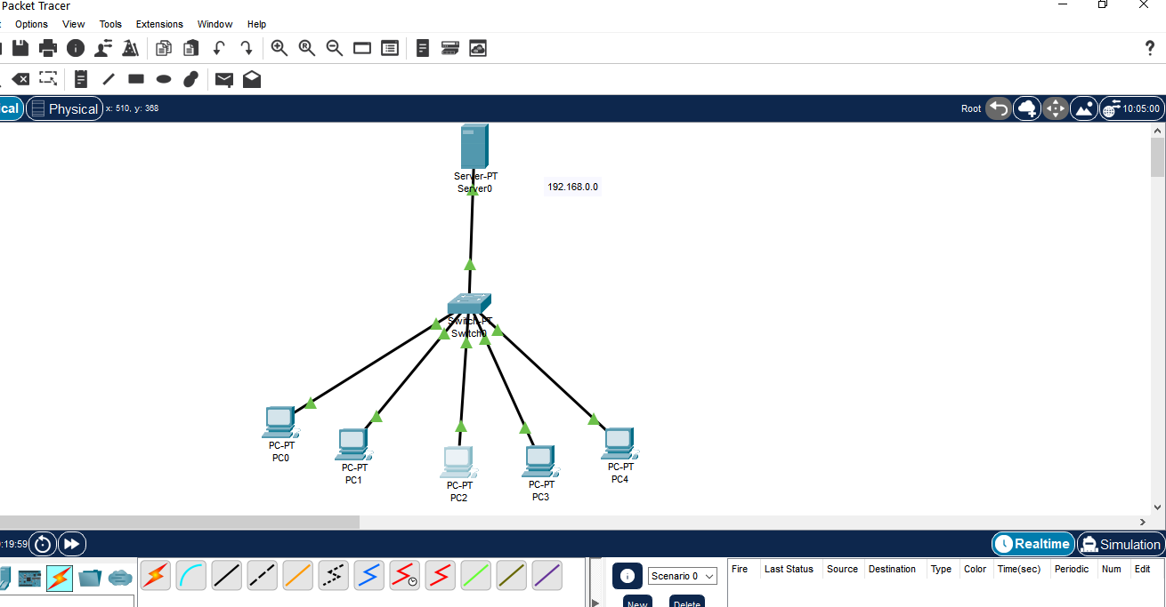

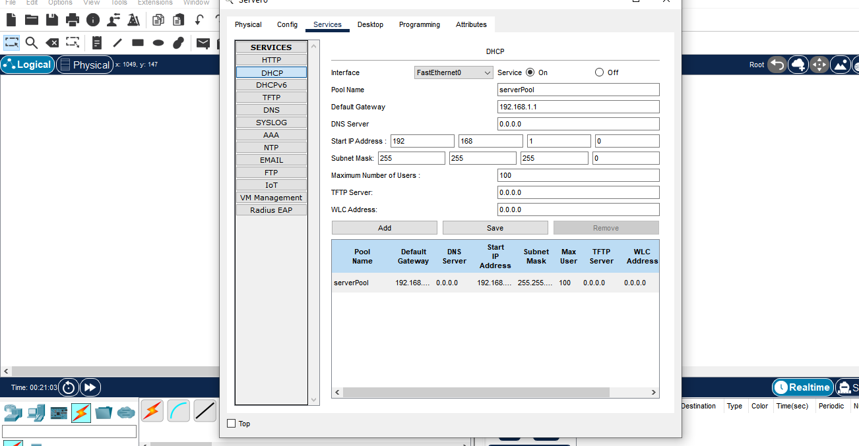

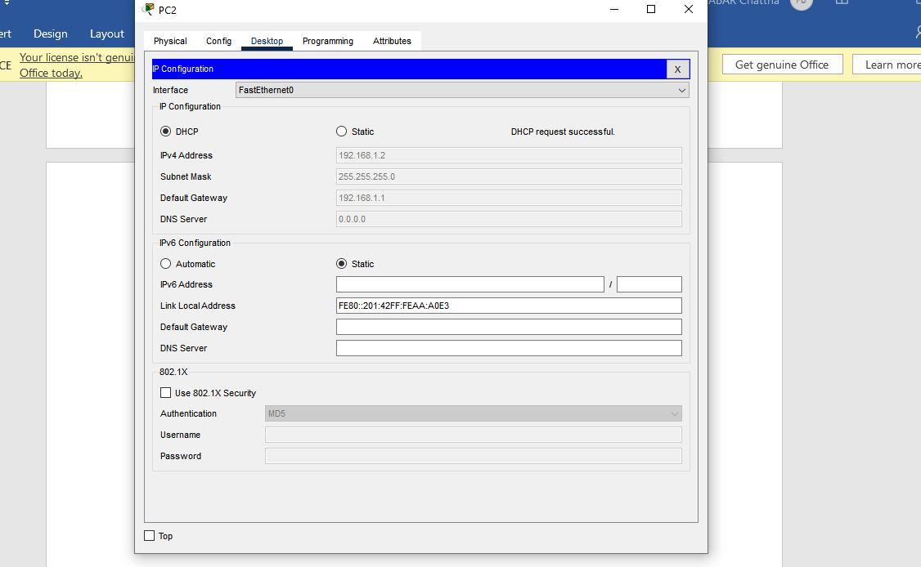

**Task 3: Implement DHCP using router.**

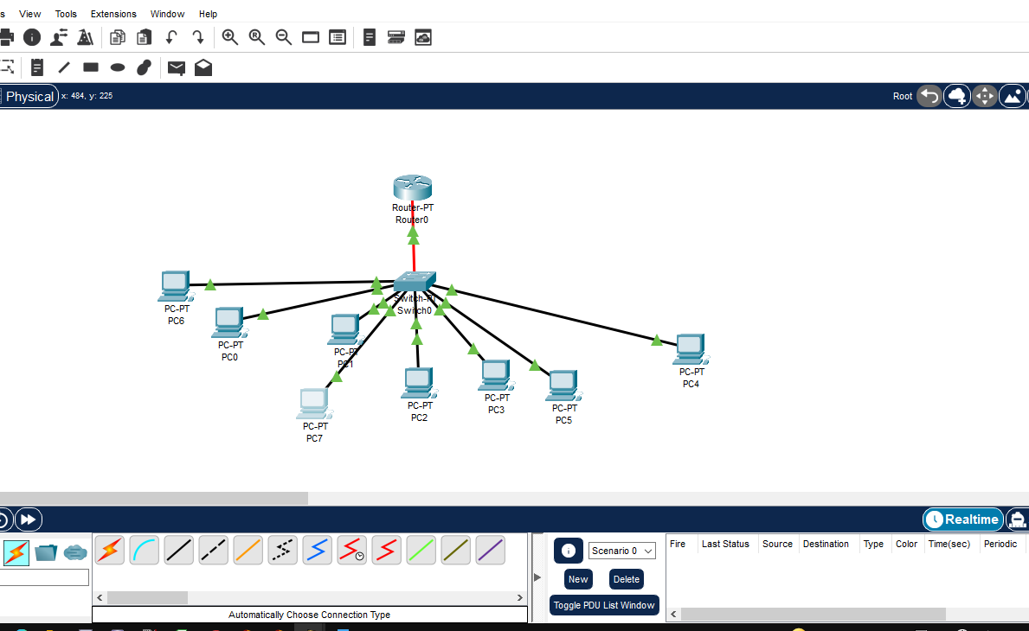

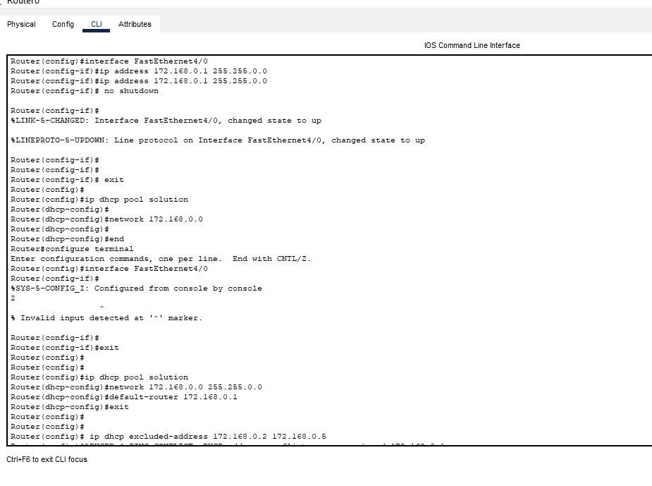

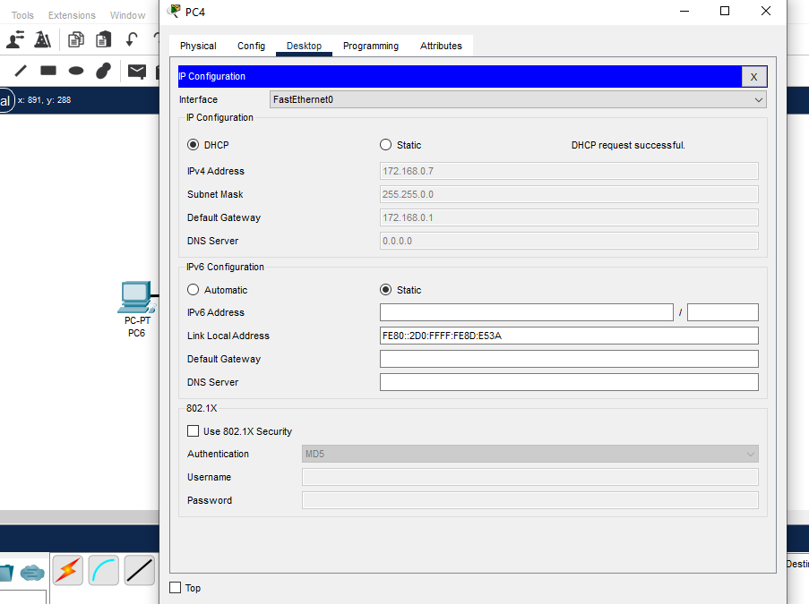

**Lab Grading Sheet :**

|  |  |  |  |
| --- | --- | --- | --- |
| **Task** | **Max Marks** | **Obtained Marks** | **Comments(*if any*)** |
| 1. | 2.5 |  |  |
| 2. | 2.5 |  |  |
| 3. | 2.5 |  |  |
| 4. | 2.5 |  |  |
| **Total** | **10** |  | **Signature** |

Note : Attempt all tasks and get them checked by your Lab. InstructorLab 11: DHCP Implementation using Packet Tracer

## Objective(s):

To implement Dynamic Host Configuration Protocol and Domain Name Services on packet tracer.

## Tool(s) used:

CISCO Packet tracer

The Dynamic Host Configuration Protocol (DHCP) is a network protocol that is used to configure network devices. DHCP allows a computer to join an IP-based network without having a pre-configured IP address. DHCP is a protocol that assigns unique IP addresses to devices, then releases and renews these addresses as devices leave and re-join the network. Internet Service Providers (ISPs) usually use DHCP to allow customers to join the Internet with minimum effort. The DHCP server maintains a database of available IP addresses and configuration information. When it receives a request from a client, the DHCP server determines the network to which the DHCP client is connected, and then allocates an IP address. DHCP servers typically grant IP addresses to clients only for a limited interval.

**Apply DHCP on packet tracer using routers.**

**Step 1:** First, make a topology with one router on which we will apply DHCP and several client PCs. More like this one,

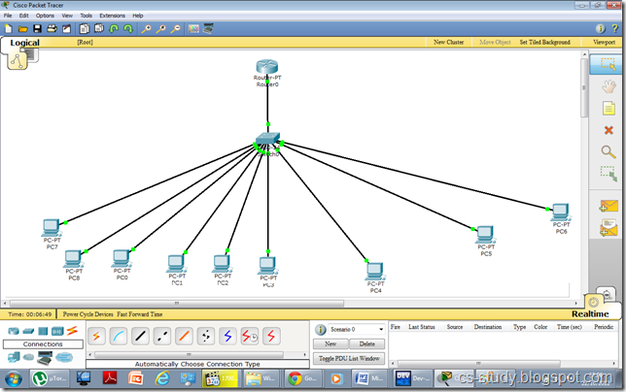

**Step 2:** Now, Apply DHCP on the router.

The commands in sequence are as follows.   
Give IP Address at router interface: 172.168.0.1

For DHCP Implementation

ip dhcp pool cisco

network 172.168.0.0 255.255.0.0

default-router 172.168.0.1

ip dhcp excluded-address 172.168.0.2 172.168.0.5

In the following command “ip dhcp pool cisco”, we are creating a  pool for DHCP called cisco. cisco is the name here and we can name it whatever we want. Give the network, and default router.

Similarly, in the command “default-router “DHCP about the default route to follow.

Notice, after we exit from DHCP mode, we are excluding some IP addresses by applying this command “ip dhcp excluded-addresses x-x”, where x is the starting and ending IP address respectively. We are basically reserving some IPs for our use. It can be used to attach printers, or assign it to some specific users for security purposes.

**Step 3:** Now, open the PC.

**Step 4:** Click on IP Configuration

**Step 5:** Select from Static to DHCP

**Step 6:** Applying some IPs in sequence, DHCP will skip the IPs that we have excluded from our DHCP pool.

**DHCP on packet tracer through Server**

**Step 1:** Apply DHCP on server and PCs will be assigned IP addresses through DHCP.

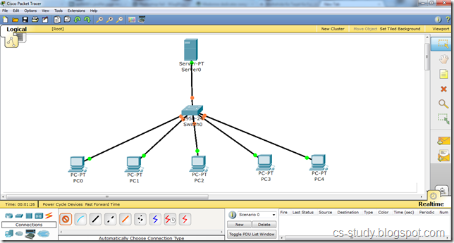

**Step 2:** Open the server and go to the Desktop tab, click IP Configuration and enter the IP address.

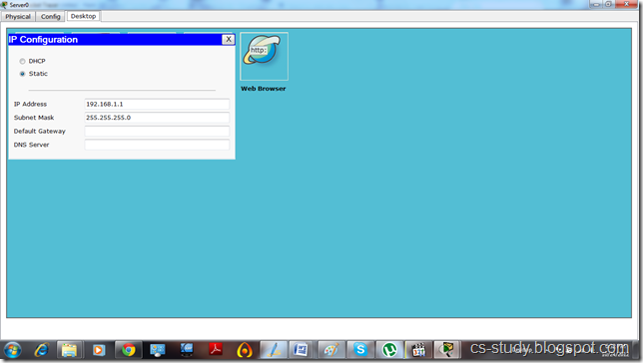

**Step 3:** Go to the Config

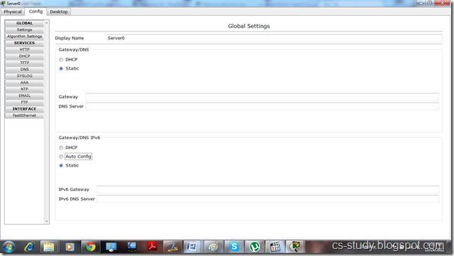

**Step 4:** Go to the DHCP

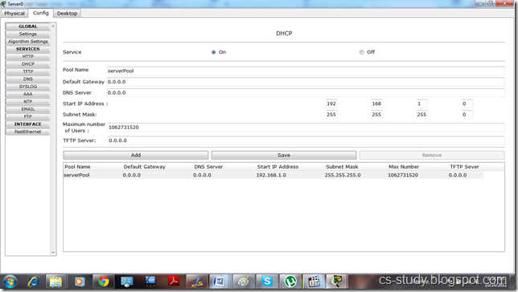

i. Enter IP for default Gateway.   
ii. Start IP address   
iii.. Maximum number of Users.   
iv. Click Save.

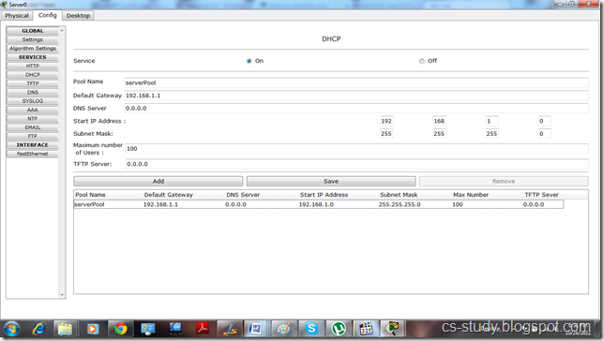

**Step 5:** Click on any PC that is attached to the server, go to IP configuration and select DHCP. You will see that DHCP will successfully assign IP address to the PC

